How to purchase classes on Brainier
- You will start on your dashboard
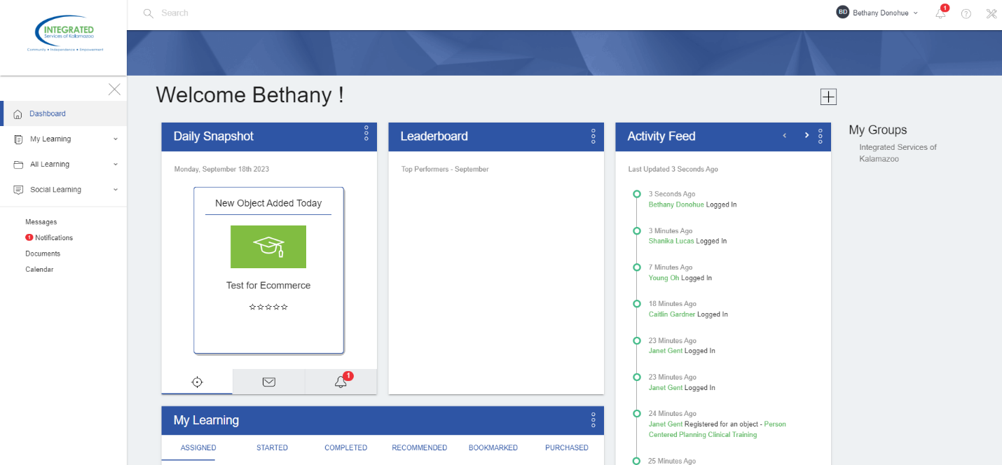
- Click on the tool icon in the top right corner
- Click on user/groups at the top, select user
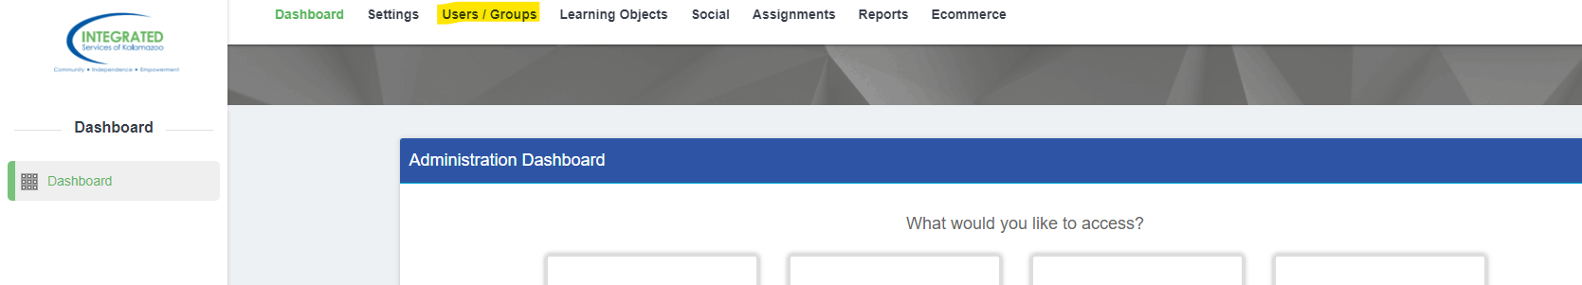
- Use search bar to find user that needs training
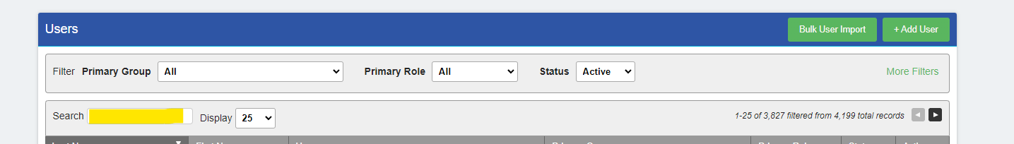
- Once you found the user you want, click on the pencil on the right hand side
- That will take you to their profile, you should see a section where you can log in as them.
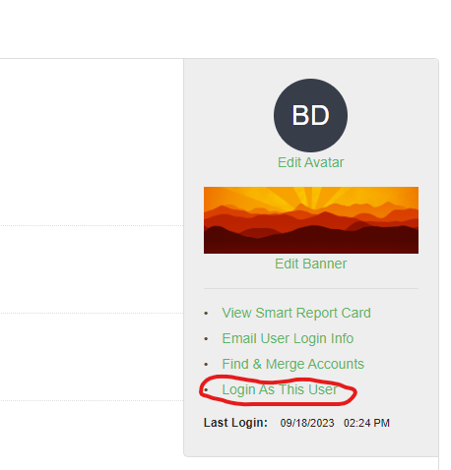
- That will take you to their profile
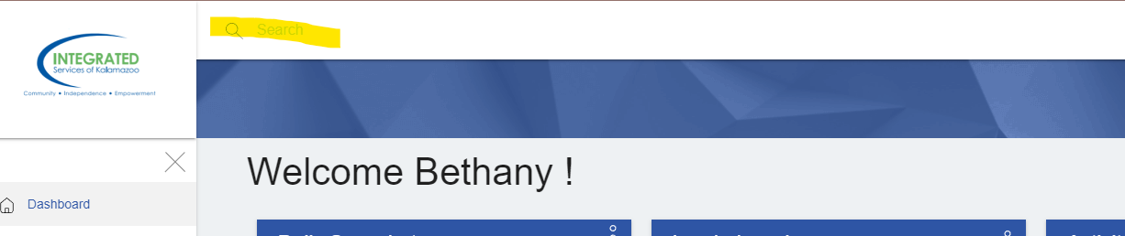
- Use search bar at the top to find classes. All your Classes are Label NP for non-provider, select the one needed.
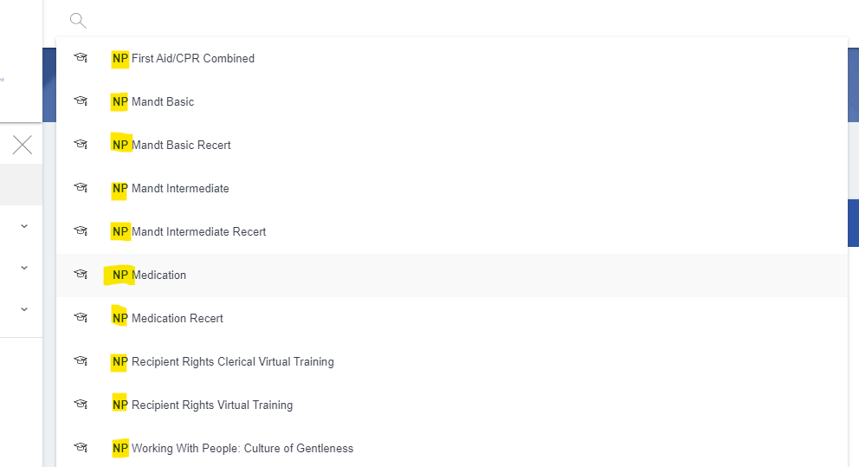
- You will see an option to add to cart, click on that,
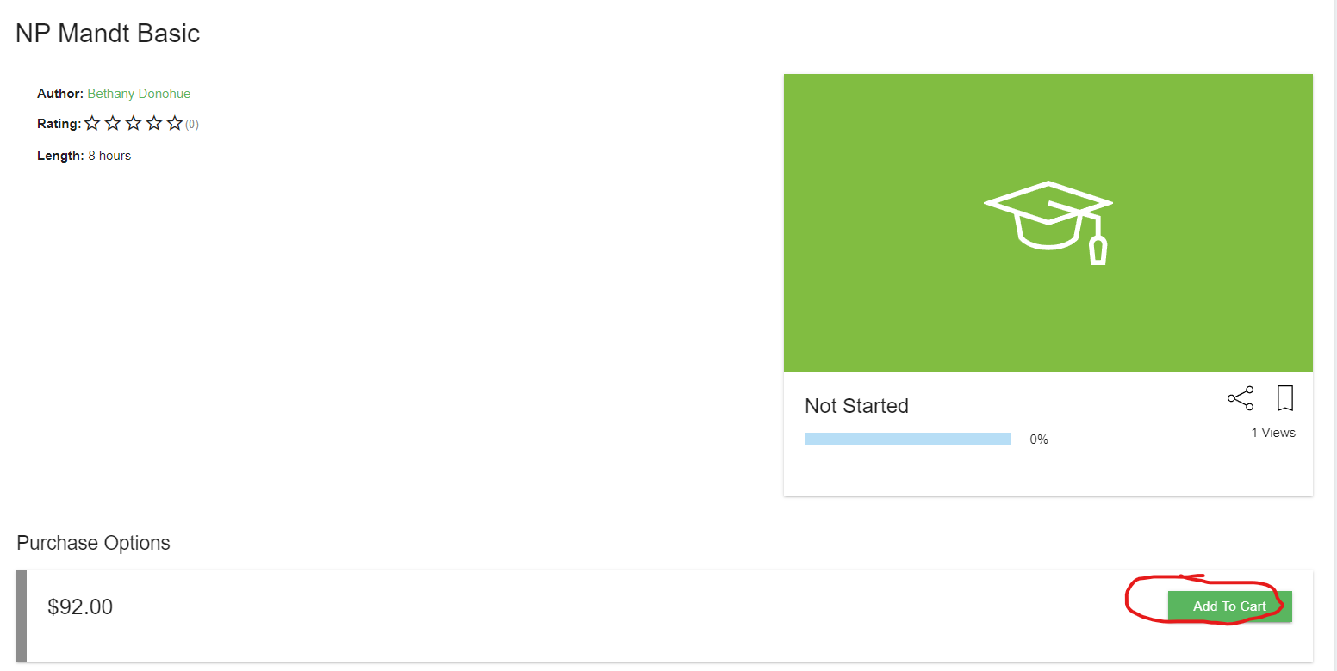
- That will bring you to a place where you can select a date. Click on arrow to bring the drop down bar down. Select the date wanted.
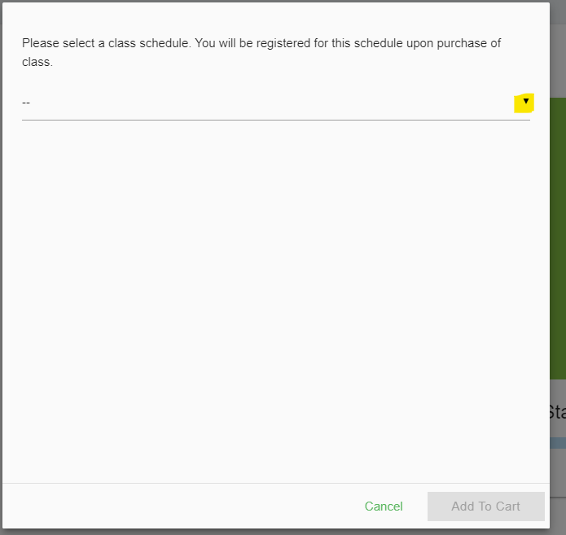
- It is at this time where you can decide to purchase more classes using the search bar at the top or you can click on the cart icon in the top right corner
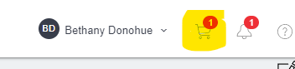
- Click on the option check out now
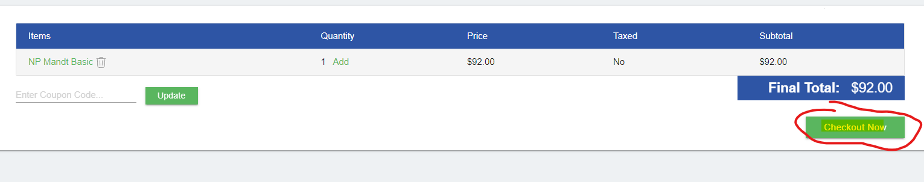
- Fill out information and then click continue
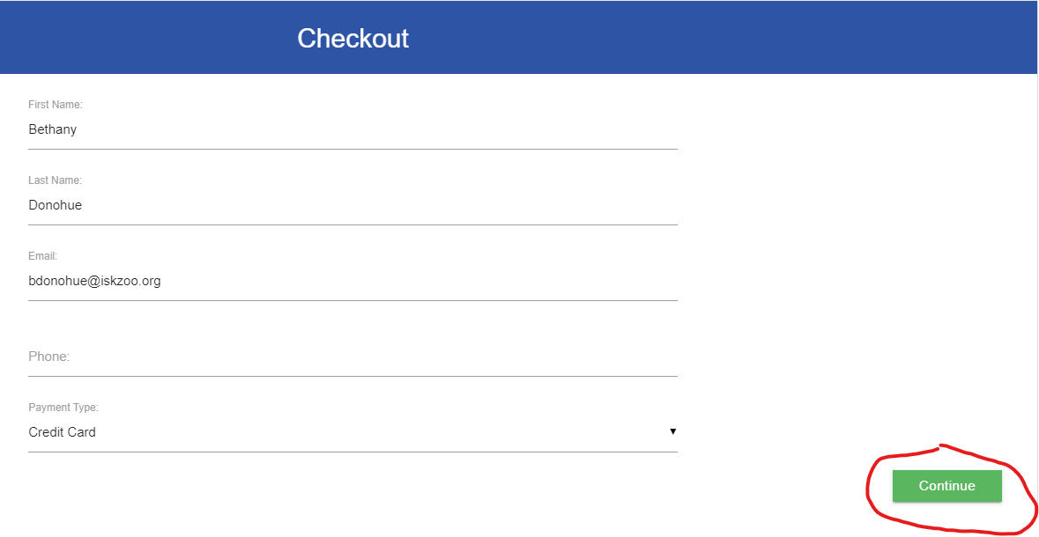
- Look over the confirm order page and click on proceed to payment.
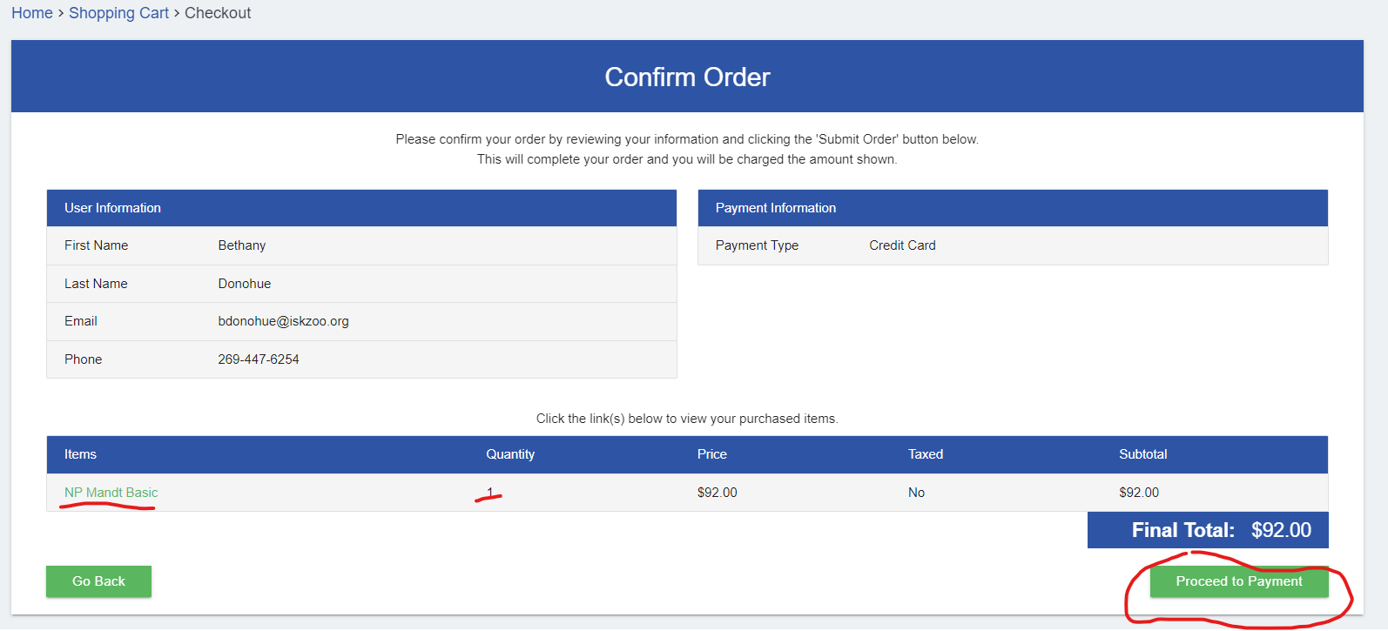
- It will then ask for your credit card information. Once that has submitted you are all set and have purchased the class.

