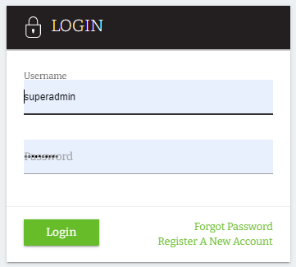
Self-Registration Process – Login Page
- Click the “Register A New Account” option

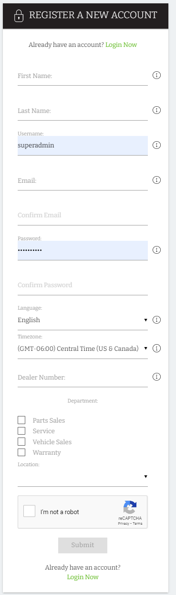
- Fill out the required fields:
First Name is required to correctly identify each learner within the learning platform.
Last Name is required to correctly identify each learner within the learning platform.
Username is required to uniquely identify each learner within the learning platform.
As superadmin, you can hide this field and make the email address to be their username
Email is used to communicate with each learner about the learning platform.

Password is required to correctly authenticate each learner in the learning platform.

Language is required to correctly display the interface for each learner within the learning platform.

Timezone is required to correctly display the time for each learner within the learning platform.
Dealer Number/group code is required to correctly categorize each learner within the learning platform. (Groups). This is needed if not default group is set up.
Department and Location are user auxiliary fields that were created to capture more user data in the registration form
CAPTCHA can be hidden or be required

Finally click LOGIN NOW

- Enter your username and password you just created in the Self-registration form:

- You will land in the front-end dashboard:
