Brainier How to sign staff up for training
You will log in and start at your dashboard:
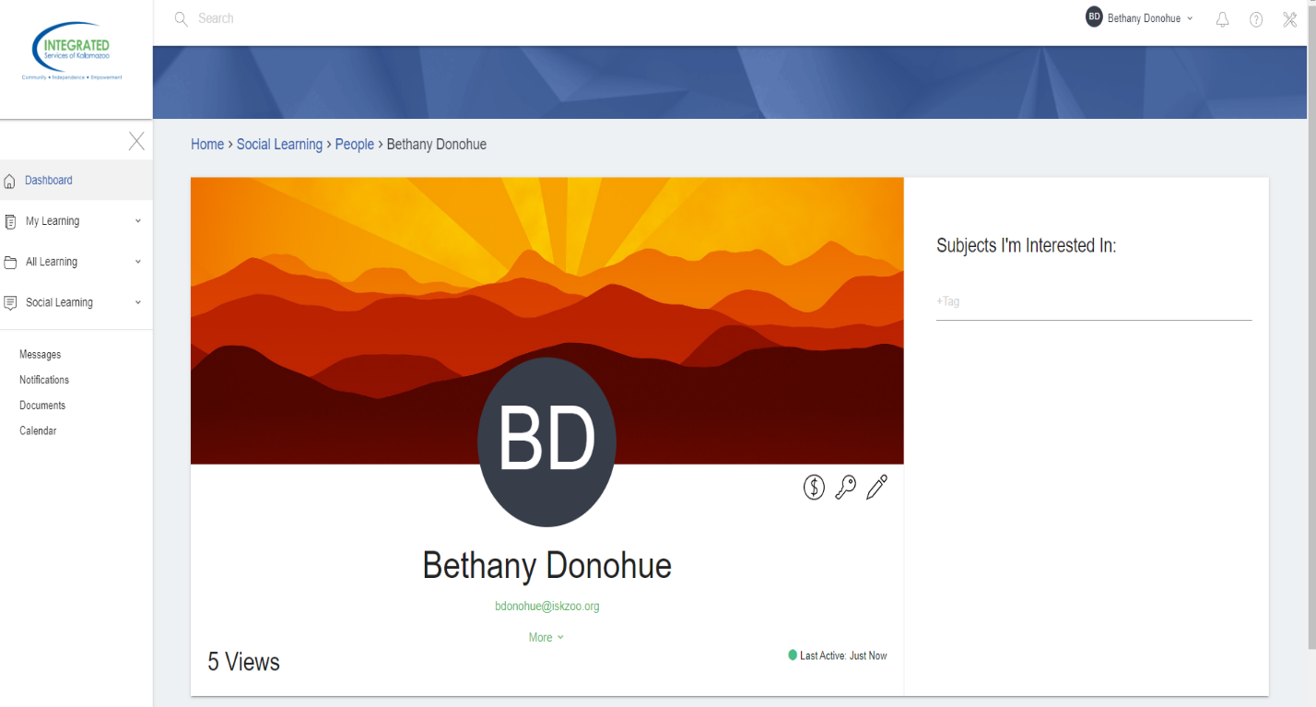

Click on the tool icon in the upper right corner of the screen
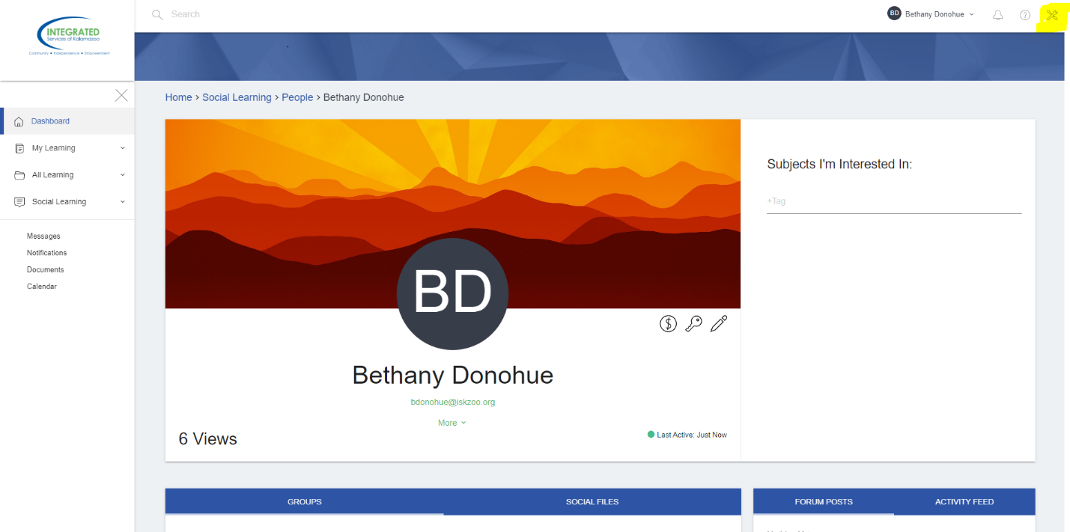

It will take you to this page where you can then click on Learning Objects at the top. 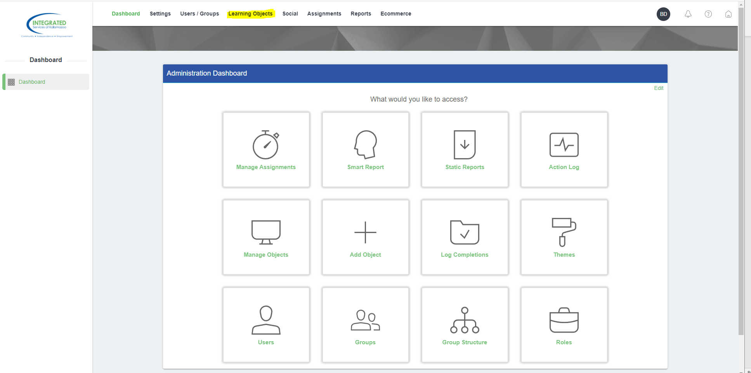
That will bring a drop down bar- Select Manage Classes

After that it will bring you to a page with all the classes. Use the search bar to search what class you are looking for.
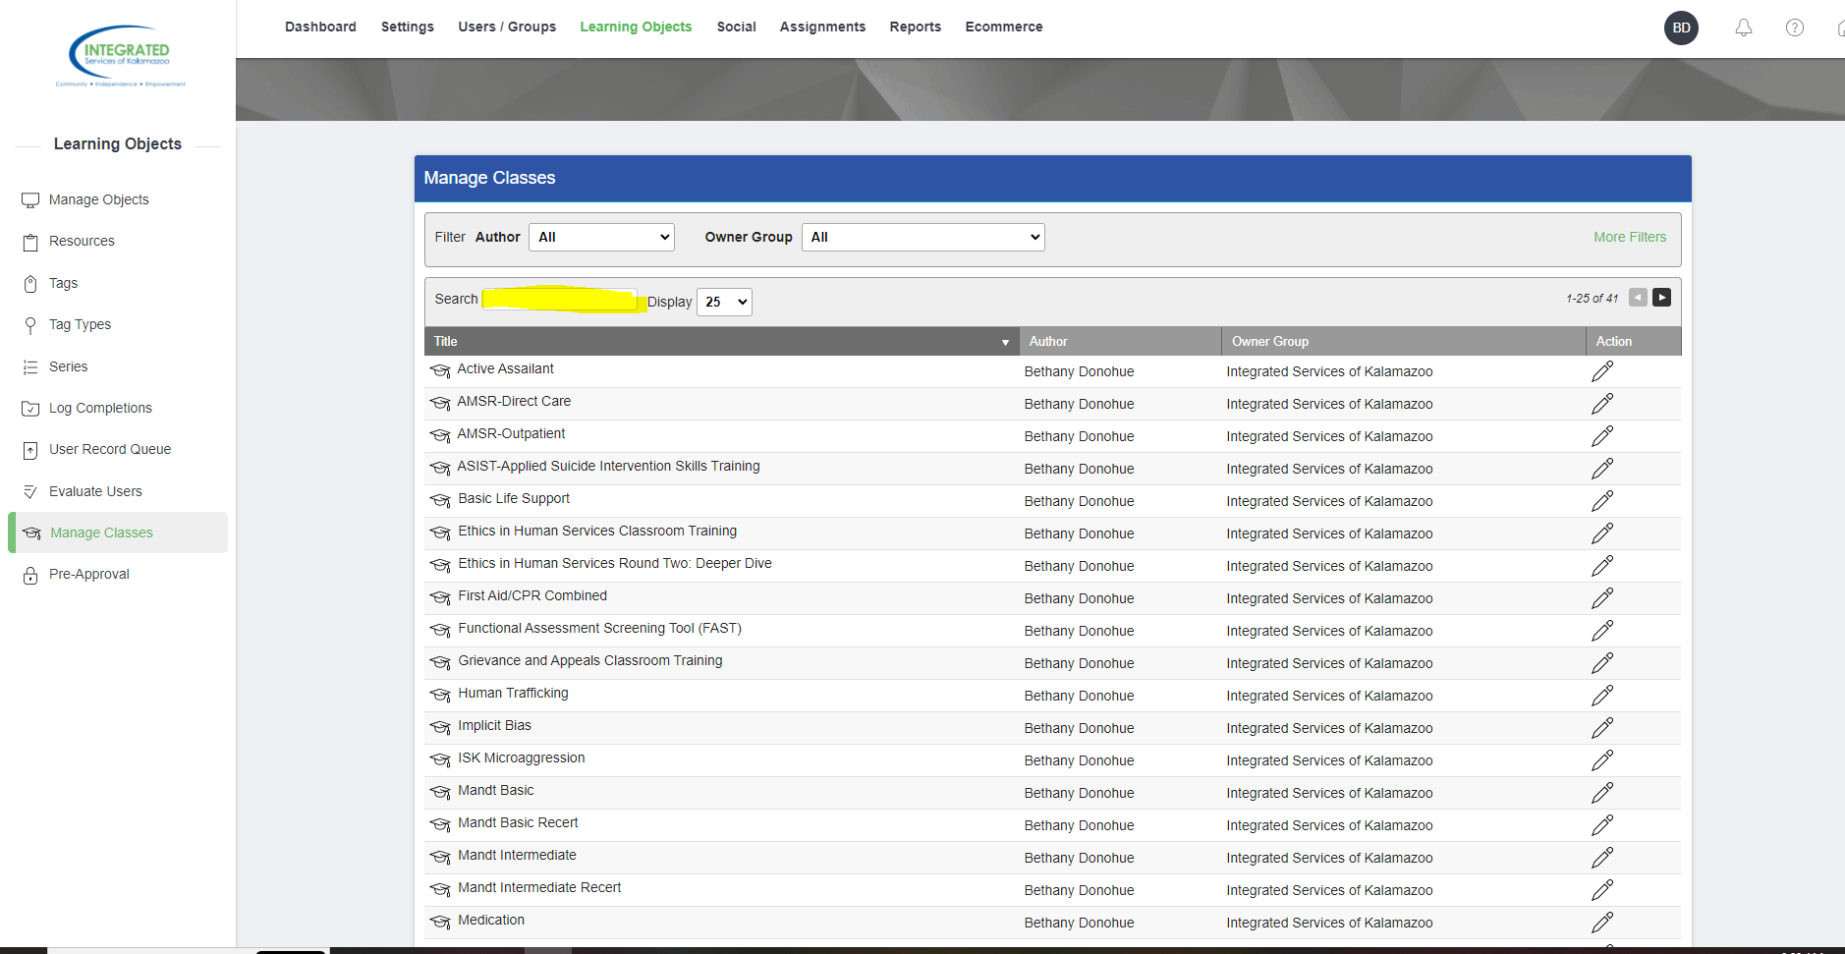

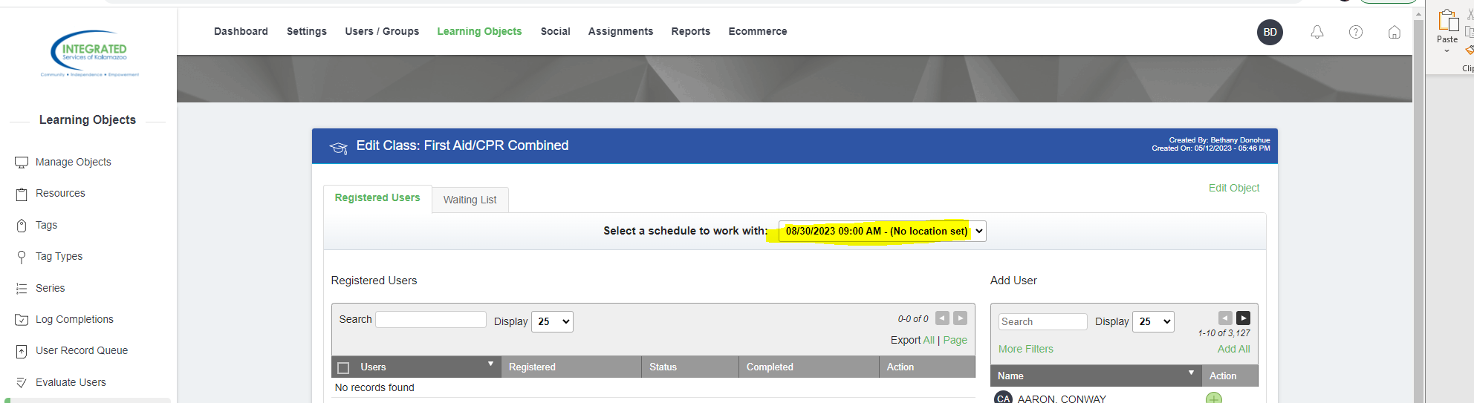
Once you have clicked on the class that you want- you will need to pick that date you want for the class. the schedule is at the top of the page. if you click on the arrow it will give you more date options.

Once you have chosen the date you want you can use the search bar under Add User- to search the staff you’d like to add.
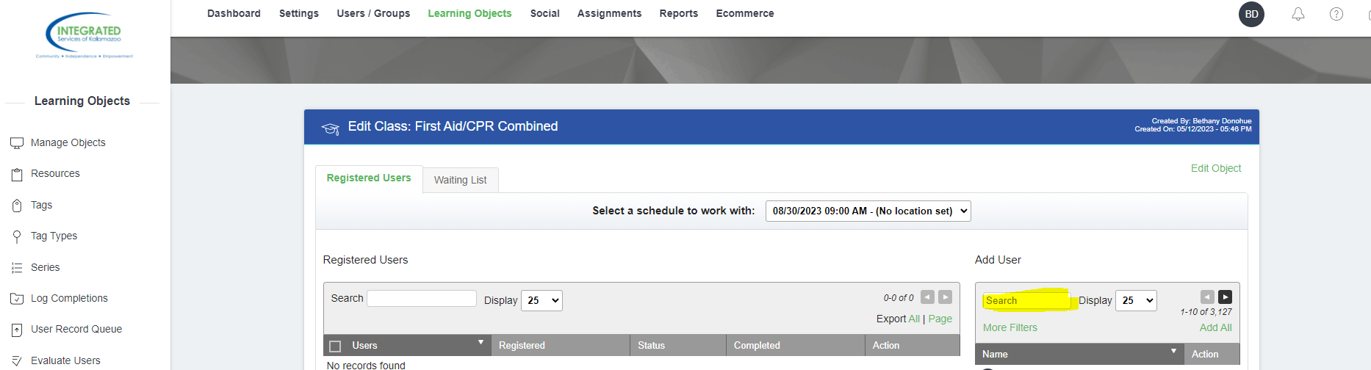

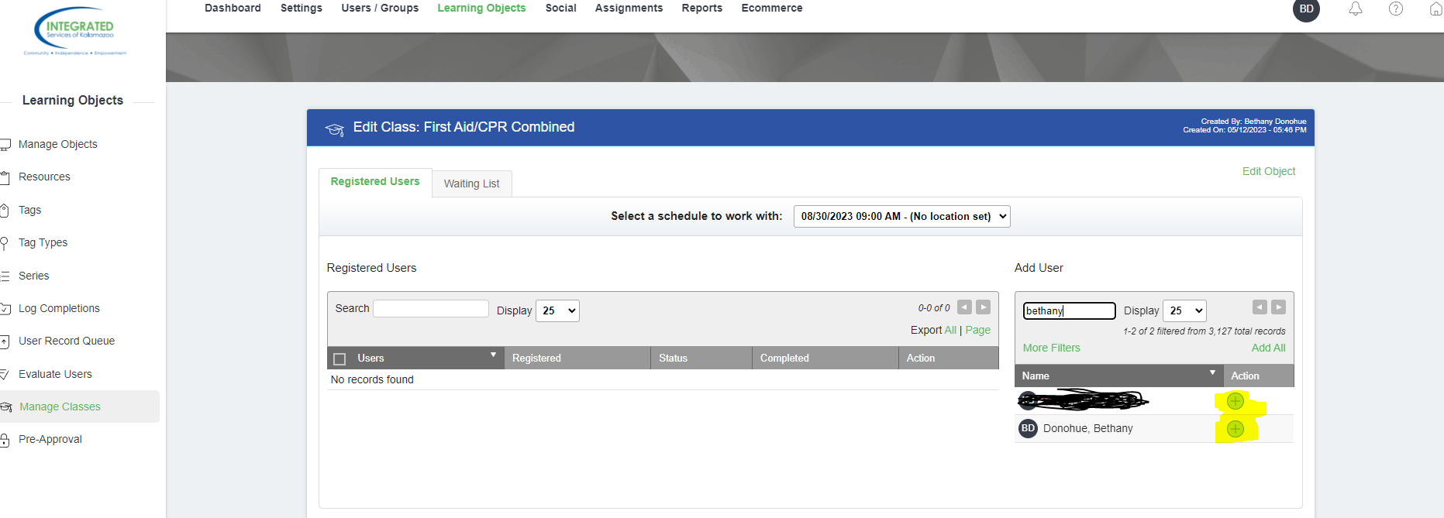
Once you’ve found the staff you want to add, click on the green plus sign next to their name.

You can now add multiple staff to one training! if you need to remove staff, just click the red X next to their name.
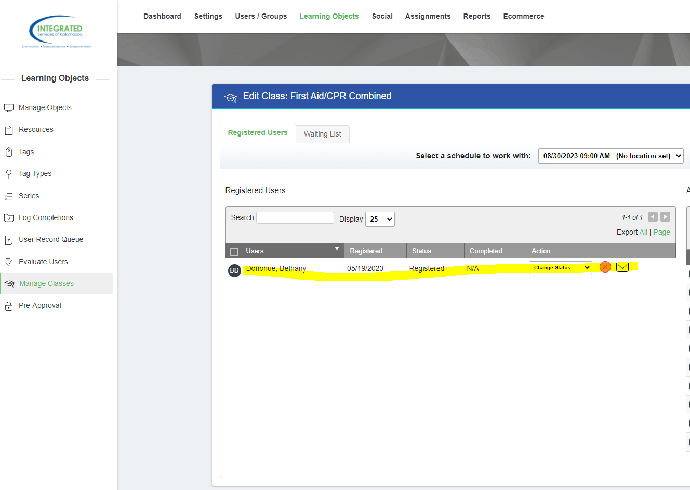

You have successfully added your staff to training!

