How to enroll Staff into Online Trainings

- You will want to log in and look for the tool icon and click on that.
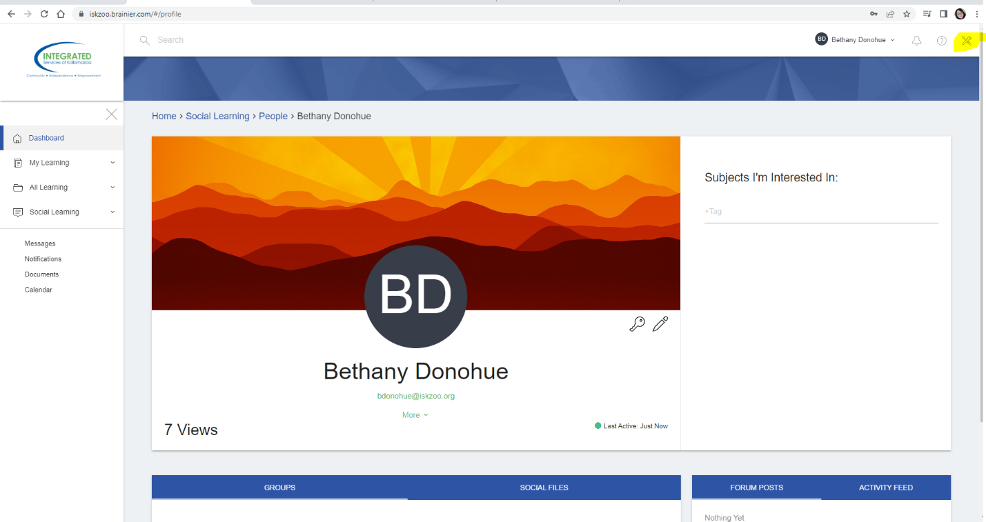
- Towards the top theres an Assignments Option, click on that and Manage Assignments
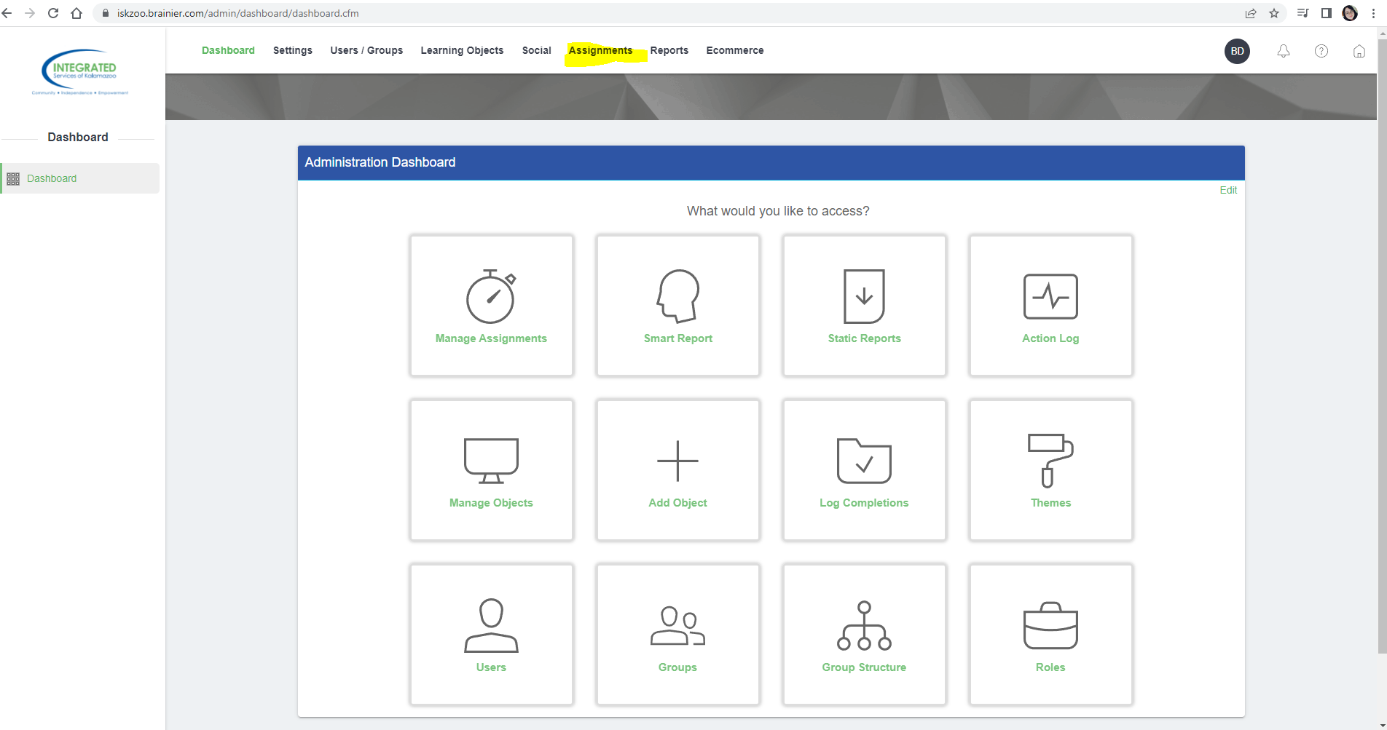

- Click on the green button in the upper right corner that says Create Assignments
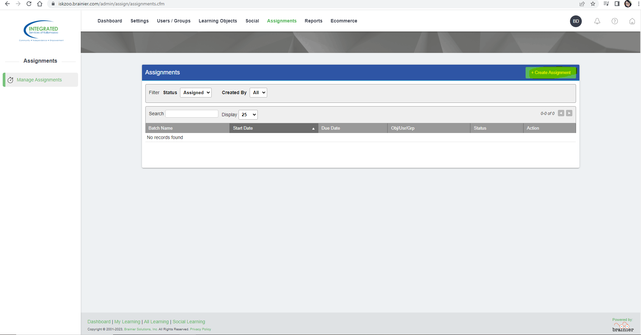
- This will bring you to a page where you can start to edit this assignment you are about to create. I would name it: Online Trainings- or something along those lines. You can also edit start and due dates.
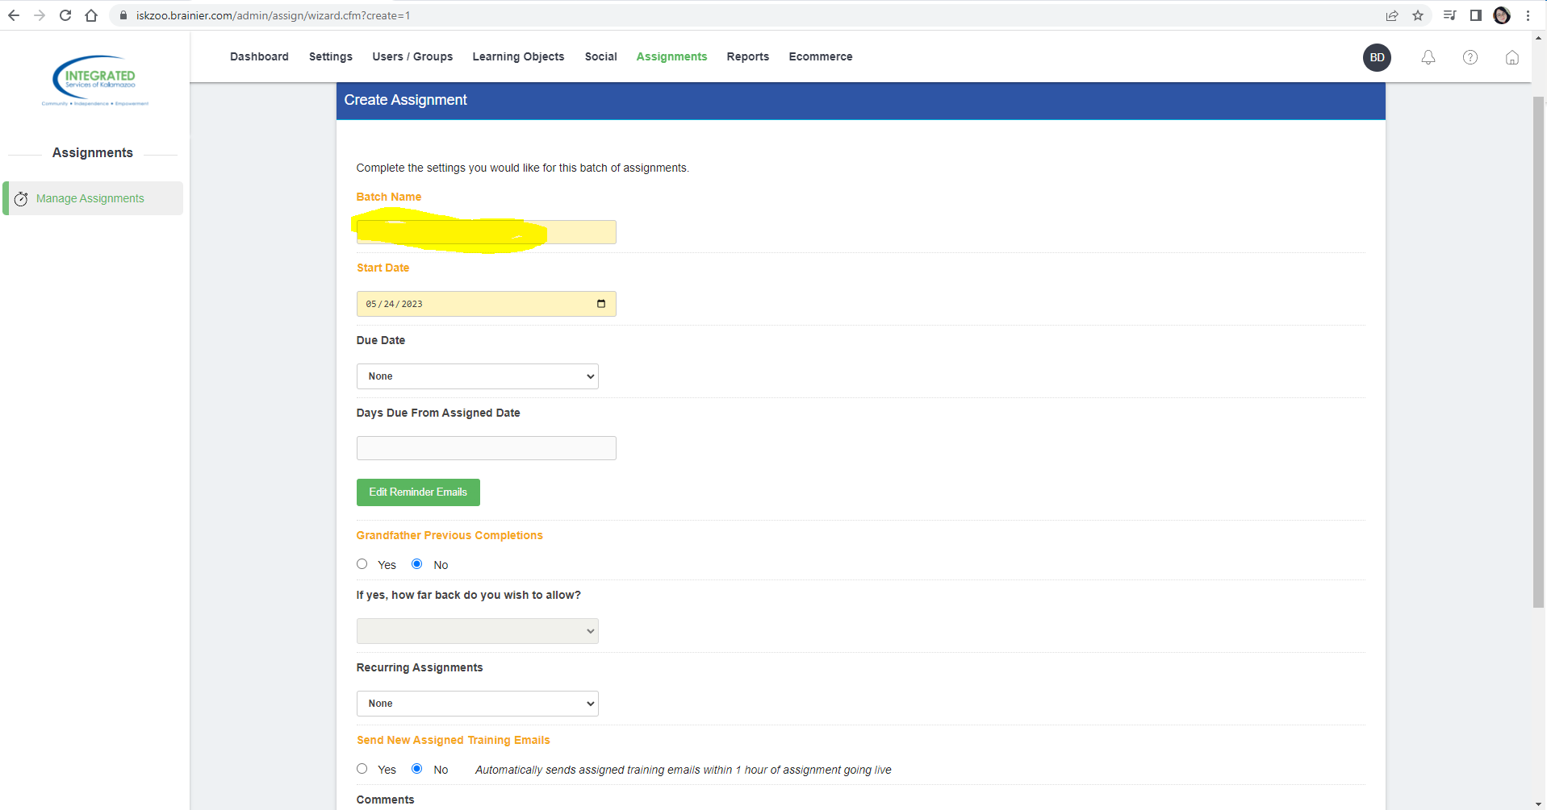

- Scroll down, you now have the options to make these online trainings Recurring! If you would like that you can select recurring, then select start date. Then type in how many days from the start date you’d like the assignment to reoccur.
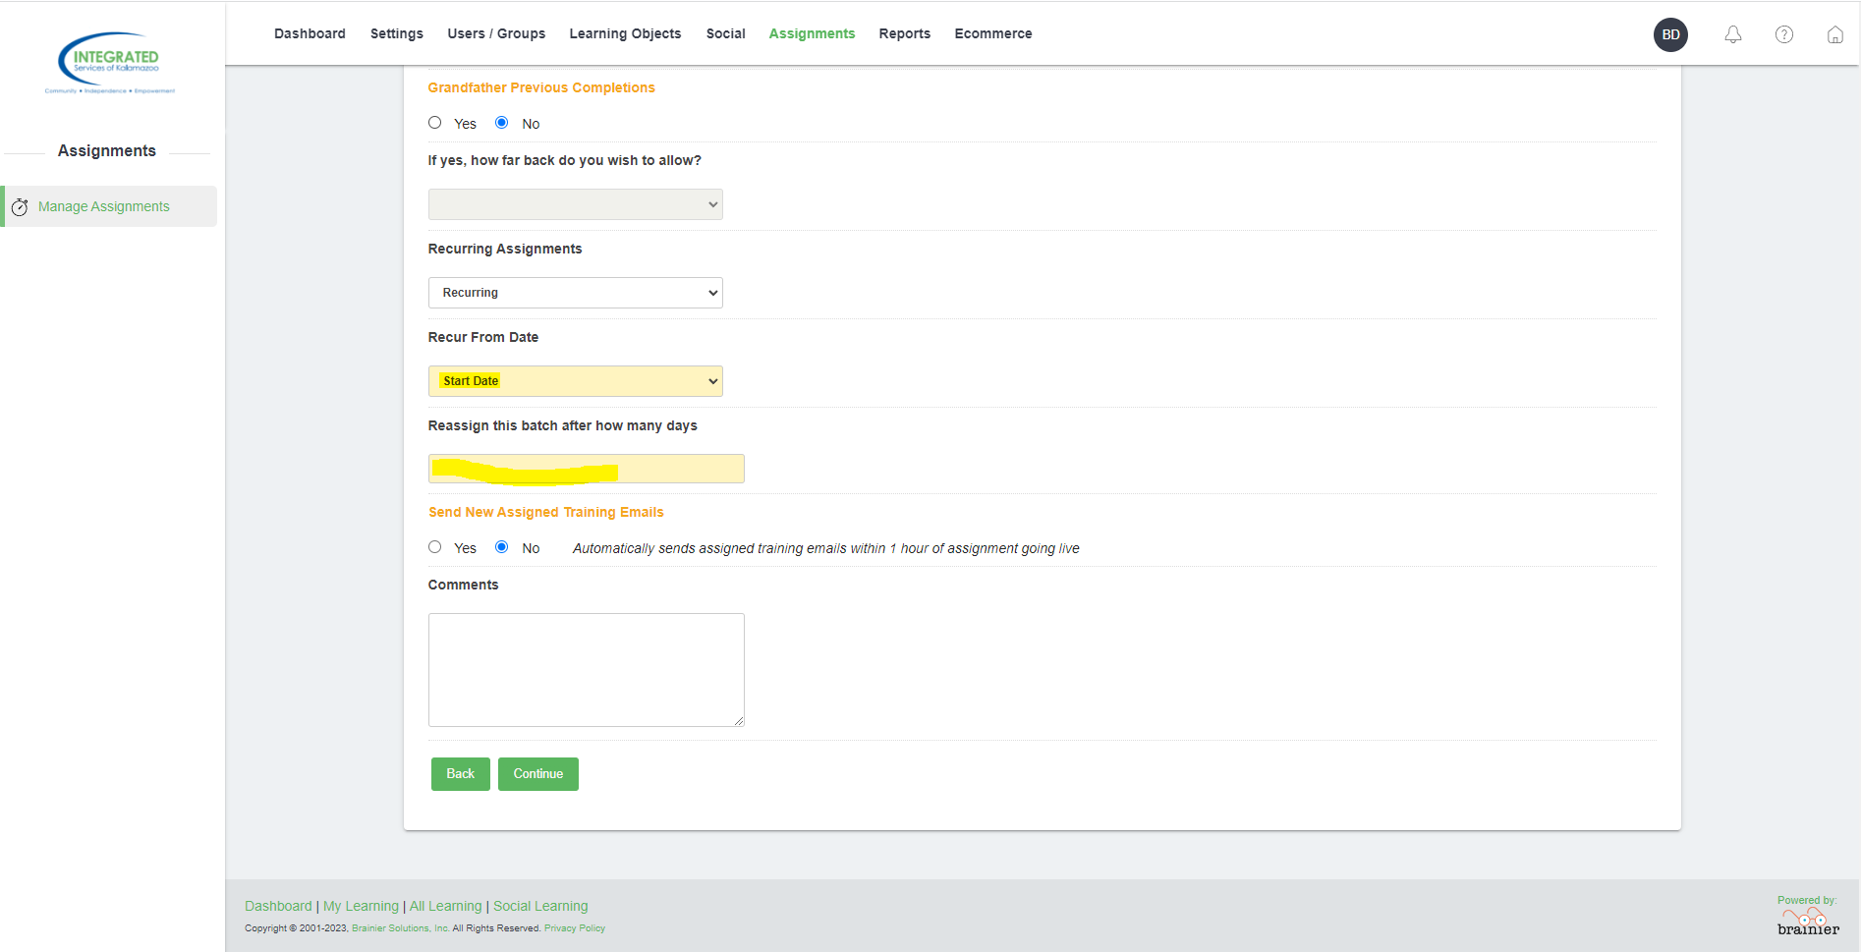
- Click continue, you will now see a page where you can add staff, you can now add multiple staff at the same time! Use the search bar and then use the green plus button to add them.
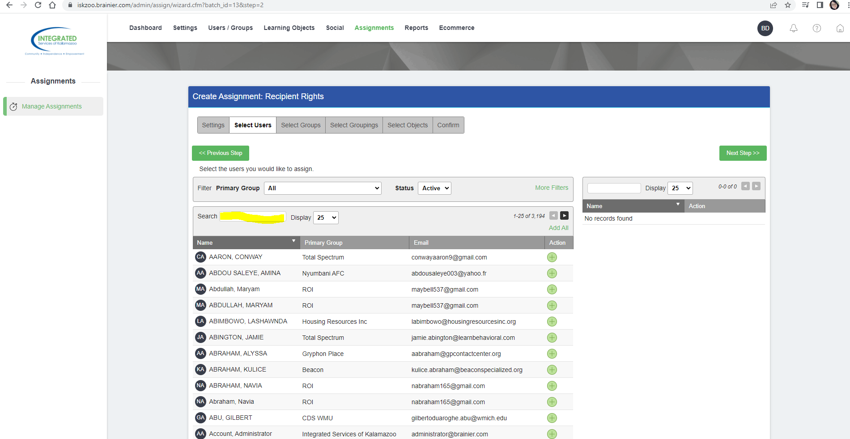

- Click on Next Step until you hit Select Objects. You can now search for the Online trainings, they are called SCORMS. You can now add multiple trainings at once!
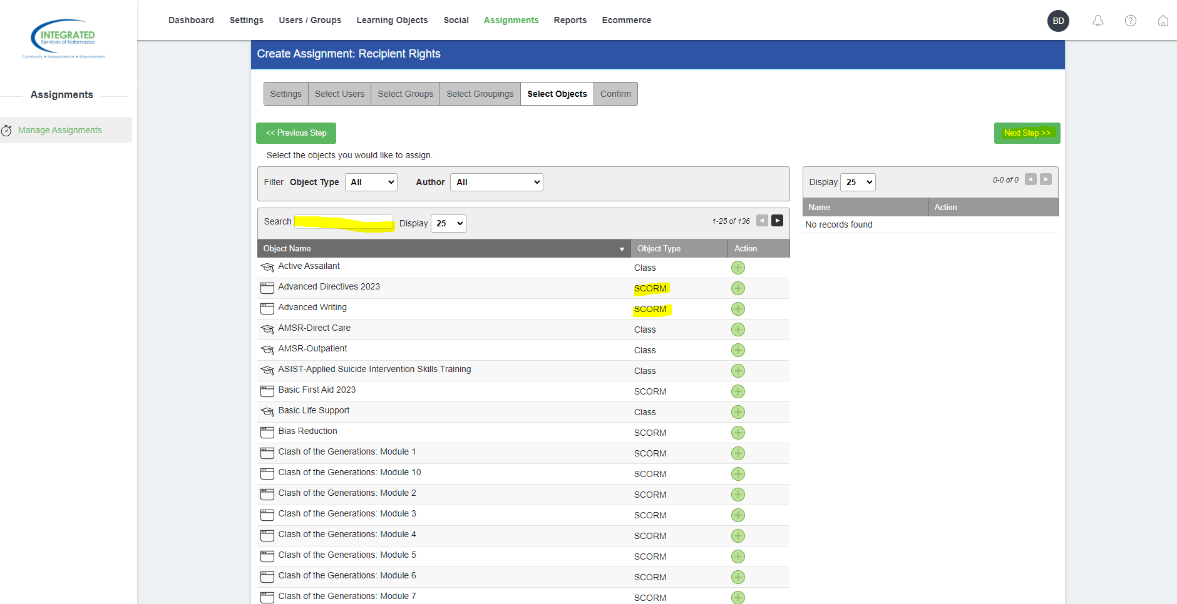
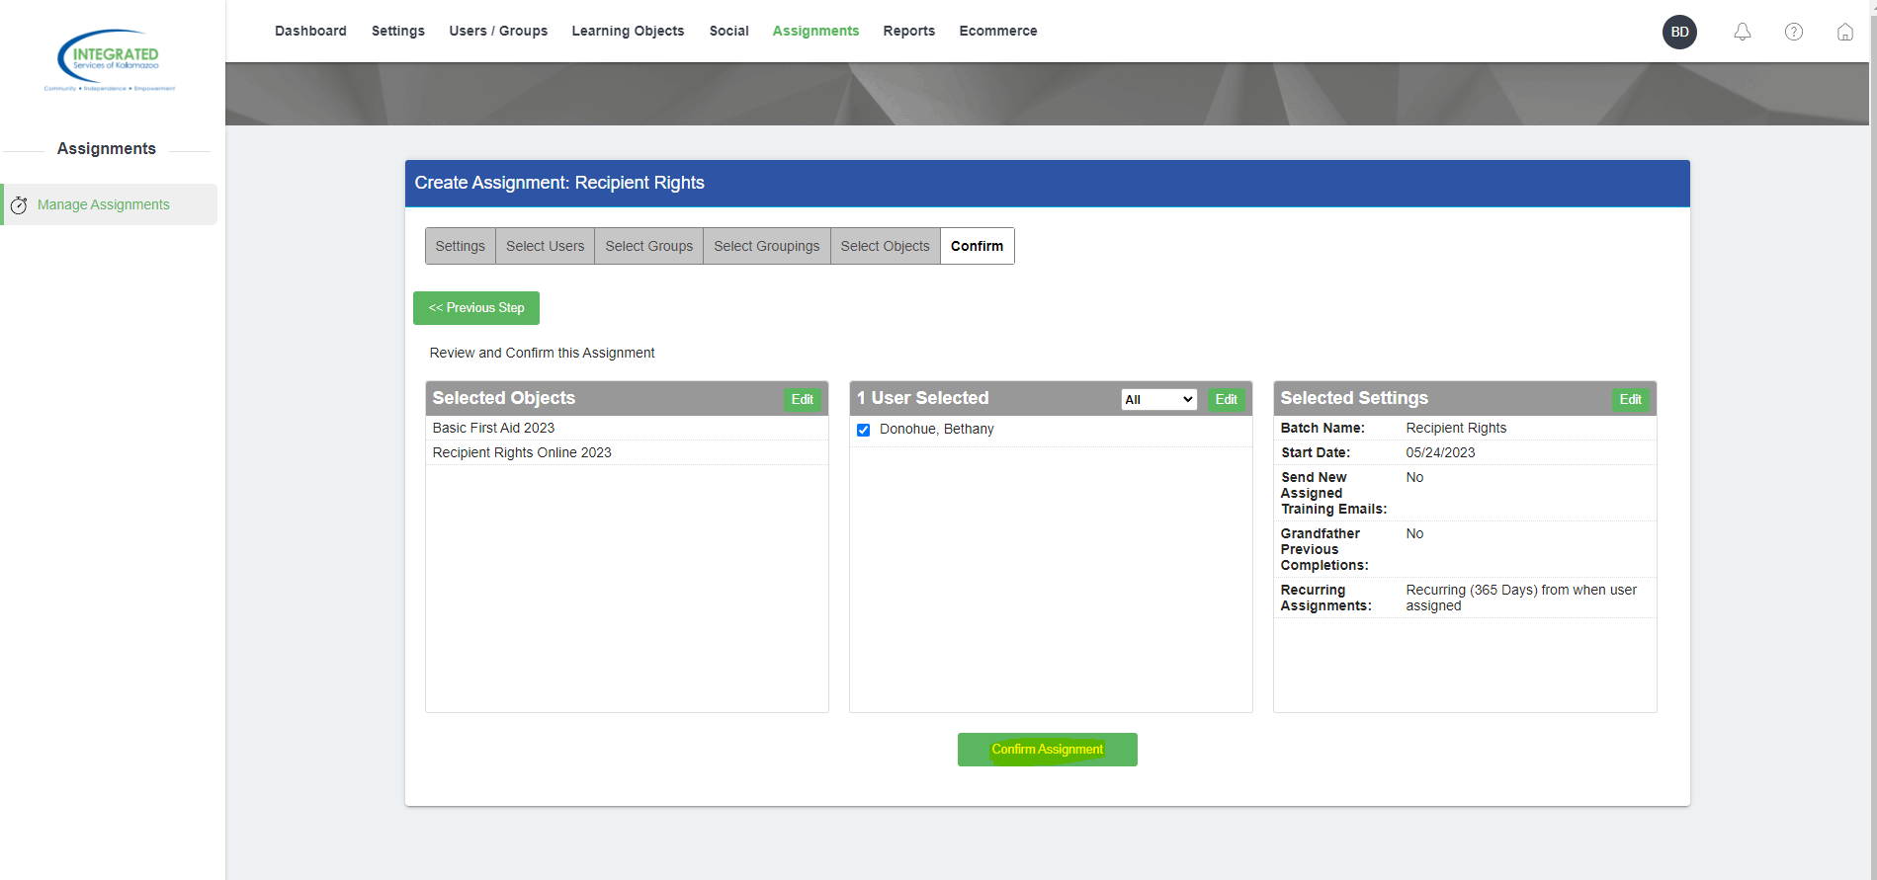
- Once you have added all the Online trainings you want to assign to staff click next step and it will take you to a page where you can edit anything you’ve done.
- Click Create Assignment- you have enrolled staff into online trainings!

