PUBLIC NOTICE for
INTEGRATED Services of Kalamazoo
*******MEETING DATE CHANGED*******

The Board of Directors of Integrated Services of Kalamazoo has moved their monthly meeting from Monday, July 25th to Monday, August 1st. The meeting
will be held @ 610 South Burdick Street, Kalamazoo, Michigan
(2nd Floor – Board Conference Room) from 4:00pm-6:30pm.

To mitigate the spread of COVID-19 and its variants, and to protect the public health by limiting in-person contact, ISK (Integrated Services of Kalamazoo) will conduct its board meeting by offering two options: Microsoft TEAMS or in-person. By utilizing these two options to conduct this meeting, we will meet the requirements of the Open Meetings Act.

All interested persons may join the remote meeting through the following procedures:

Microsoft Teams meeting
+1 616-272-5624 United States/Conference ID: 870 664 203#
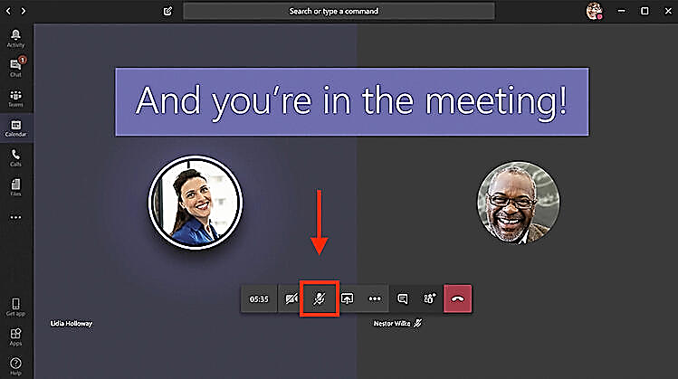
Once you have joined the meeting, please disable your camera, and silence your microphone.

See example.

ISK welcomes and encourages persons to supply input or ask questions on any board business. To communicate with the ISK Board Members or if you have specific needs to take part in the meetings held by the Board. Please contact Demeta J. Wallace at least three (3) business days prior to the scheduled meeting date at Dwallace@iskzoo.org or 269-553-8000.

The ISK Board packet is posted monthly on our website @ www.iskzoo.org.

